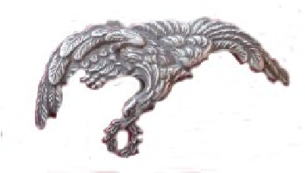POLISH AIR FORCE MEMORIAL COMMITTEE

**63rd REUNION LUNCH – SATURDAY 31st AUGUST 2024**

13.30 for 14.00, Officers’ Mess, RAF Northolt (Entry by Main Gate)

**BOOKING FORM**

**PLEASE BRING PHOTO ID AND ENTRY TICKETS (mandatory for entry)**

|  |  |  |  |  |  |  |  |  |
| --- | --- | --- | --- | --- | --- | --- | --- | --- |
| Name: | | …………………………………………………………………………. | | | | | | |
| Address: | | ………………………………………………………………………….  ………………………………………………………………………….  …………………………………………………………………………. | | | | | | |
| Tel:........................ | | e-mail……………………………………………………………… | | | | | | |
| Lunch tickets | Name | | | Dietary Needs | | | Cost | £ |
| Applicant |  | | |  | | | £ 40* |  |
| Guest 1 |  | | |  | | | £ 40 |  |
| Guest 2 |  | | |  | | | £ 40 |  |
| Guest 3 |  | | |  | | | £ 40 |  |
| Optional donation to PAFMC Funds: | | | | | | | |  |
| *\* No charge for veterans* | | | | | | | **Total:** |  |
| **Vehicle Details** | |  |  | | |  | | |
| Make | | Model | Colour | | | Registration No. | | |
| For **Descendants** of members of the Polish Air Force, please complete below | | | | | | | | |
| Name | | Rank | | | Your relationship | | | |
|  | |  | | |  | | | |

Payment by Bank Transfer to **HSBC Bank, Sort Code 40-02-13,** **Account Number 11709917** with your name and PAFMC Lunch as the reference. Otherwise by cheque for **£** …………… made out to **PAFMC.**

Please send this form and SAE (for return of tickets) to: **Chris Norman, PAFMC Reunion Lunch, Los Altos, Hedgerley Lane, Gerrards Cross, Buckinghamshire, SL9 8SX.**

*Please note: Applications should be received* ***by 26th July****. Due to the high demand for places, we cannot guarantee that all applications will be successful; if the event is oversubscribed payments will be refunded.*