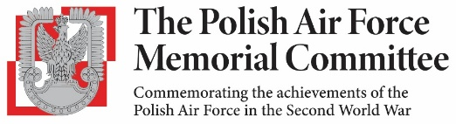
65th REUNION LUNCH – SATURDAY 29th AUGUST 2026
12 30hrs for 13 00hrs, Officers’ Mess, RAF Northolt (Entry by Main Gate)
BOOKING FORM
PLEASE BRING PHOTO ID AND ENTRY TICKETS (mandatory for entry)
Name: |  | …………………………………………………………………………………………
Address: |  | …………………………………………………………………………………………  …………………………………………………………………………………………
Tel:........................ |  | e-mail………………………………………………………………………………….
Lunch tickets | Name |  |  | Dietary Needs |  |  | Cost | £
Applicant |  |  |  |  |  |  | £ 55
Guest 1 |  |  |  |  |  |  | £ 55
Guest 2 |  |  |  |  |  |  | £ 55
Guest 3 |  |  |  |  |  |  | £ 55
Optional donation to PAFMC Funds:
 |  |  |  |  |  |  | Total:
Vehicle Details
Make |  | Model | Colour |  |  | Registration No.
For Descendants of members of the Polish Air Force, please complete below
Name |  | Rank/Squadron |  |  | Your relationship

Payment by Bank Transfer to HSBC Bank, Sort Code 40-02-13, Account Number 11709917 with your name and PAFMC Lunch as the reference. Otherwise by cheque for £ …………… made out to PAFMC.

Please send this form and SAE (stamped addressed envelope) for return of tickets to: Chris Norman, PAFMC Reunion Lunch, Los Altos, Hedgerley Lane, Gerrards Cross, Buckinghamshire, SL9 8SX.

Please note: Applications should be received by 29th June 2026. Due to the high demand for places, we cannot guarantee that all applications will be successful; if the event is oversubscribed payments will be refunded.

